Subject 04 data analysis 01nov2011
01nov2011 Decision: JR should re-do DF=4,5,6

This includes re-analysis… for DF=4 5 6 that had previously been mis-arranged ( results from multiple trials into wrong components of result.data.) On 01nov2011 JR re-arranged correctly. The data here for DF =3 and 7 are OK

DF=3 3 trials.

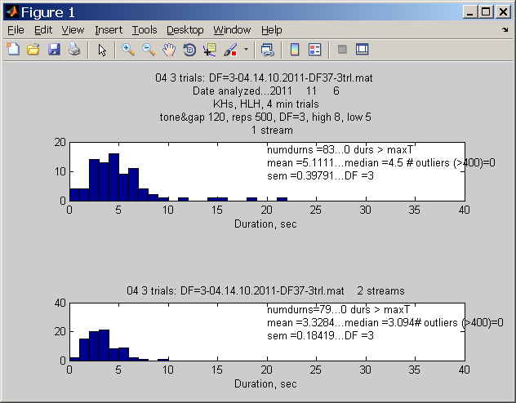

Stats for --04 - 3 trials...DF=3
m04df3 =
83.0000 5.1111 4.5000 0.3979 3.0000 1.0000
79.0000 3.3284 3.0940 0.1842 3.0000 2.0000

DF=4 3 trials. 01nov2011
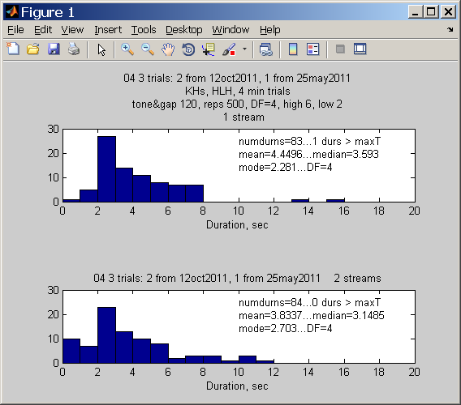
Stats for --04 - 3 trials...DF=4
83.0000 4.4496 3.5930 2.2810
84.0000 3.8337 3.1485 2.7030

DF=5. 3 trials. (Re-ordered is on right col)

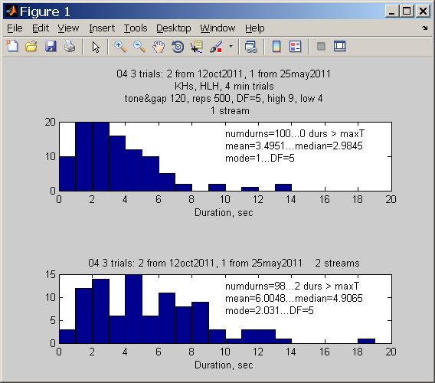
Stats for --04 - 3 trials...DF=5

100.0000 3.4951 2.9845 1.0000
98.0000 6.0048 4.9065 2.0310

DF=6. 3 trials. JR is this (on the right col) correct??? How can this come out to be the same as with mis-arranged earlier data??

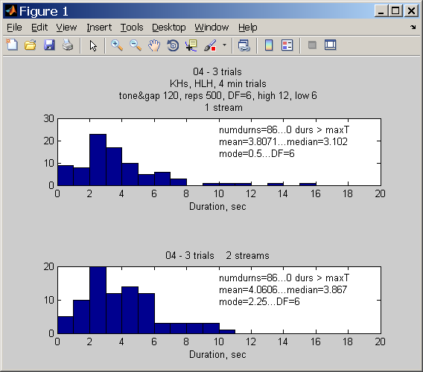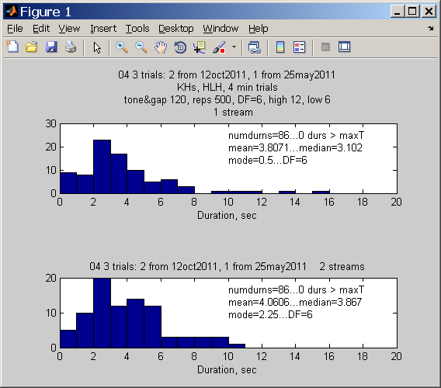

Stats for subj: 04 - 3 trials...DF=6

86.0000 3.8071 3.1020 0.5000
86.0000 4.0606 3.8670 2.2500

DF=7, 3 trials.
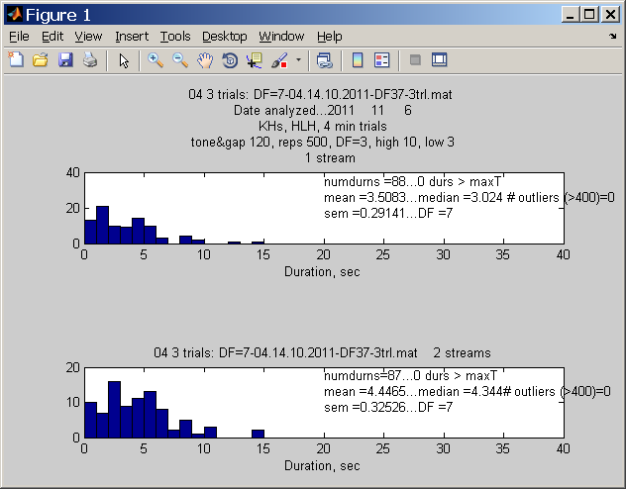ffd

Stats for --04 - 3 trials...DF=7
m04df7 =
88.0000 3.5083 3.0240 0.2914 7.0000 1.0000
87.0000 4.4465 4.3440 0.3253 7.0000 2.0000

+++++++++++
++++++++++++

